**Week/ TASK 7**

•Find out what Responsible AI is?

• Find instances where AI has failed? Or been used maliciously or incorrectly.

• Implications of when AI fails. There is a specific article in the GDPR Law that covers this, especially with automated decision making. (opt in and out options).

• What should organisations do to ensure that they are being responsible with AI and the wider use of data in general?

Responsible AI is a governance framework that documents how a specific organization is addressing the challenges around artificial intelligence (AI) from both an ethical and legal point of view (Singer,2020). Having the obligation to do something or control over something pertains to being responsible. On the otherhand, artificial intelligence pertains to activities done by computer.

Singer (2020), further states that Responsible AI involves developing and operating artificial intelligence systems that integrate human empathy, creativity, and care to ensure that they work in service to the greater good while achieving transformative business impact.

Google has shown several examples where AI fails. One example which I find really scary, if I will be a customer. A hotel in Japan makes use of robots as staff: the front-desk, cleaners, porters and in-room assistants. Eventually, after few years of serving customers, the hotel accumulates complaints since the bots frequently broke down, could not provide satisfactory answers to guest queries, and in-room assistants startled guests at night by interpreting snoring as a wake command. In the end, they have a scared and unhappy customer which results in withdrawing all the AI employees. Another good example I can think of, although it is fictional, are the AI’s used by Tony Stark in Marvel movies Iron Man, Avengers and Spiderman. JARVIS (Just A Rather Intelligent System), FRIDAY (Female Replacement Intelligent Digital Assistant Youth) and EDITH (Even Dead I’m The Hero) are the AI’s used in these movies. Even in the movies, wherein they can make it perfect, they still show some flaws of AI. EDITH almost killed everyone in the bus when Peter state that Brad is the “target”.

One of the Responsible AI’s initiative is to resolve any vagueness, especially when things go wrong, somebody needs to be responsible for it. General Data Protection Regulation (GDPR) Article 6 provides extensive information about lawfulness of data collection processing. In this article, it reiterated that processing shall be lawful only if some conditions are followed, specifically, processing is necessary for the purposes of the legitimate interests pursued by the controller or by a third party, except where such interests are overridden by the interests or fundamental rights and freedoms of the data subject which require protection of personal data.

From the article, “The Challenge of Defining Responsible AI”, by Sean Singer, 2020, it clearly specifies what Responsible AI mean on (Table 1) as well as 7 Ways AI system fail in Table 2.

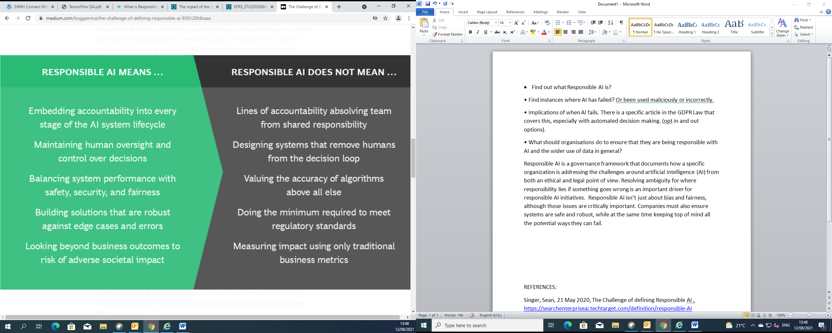

Table 1

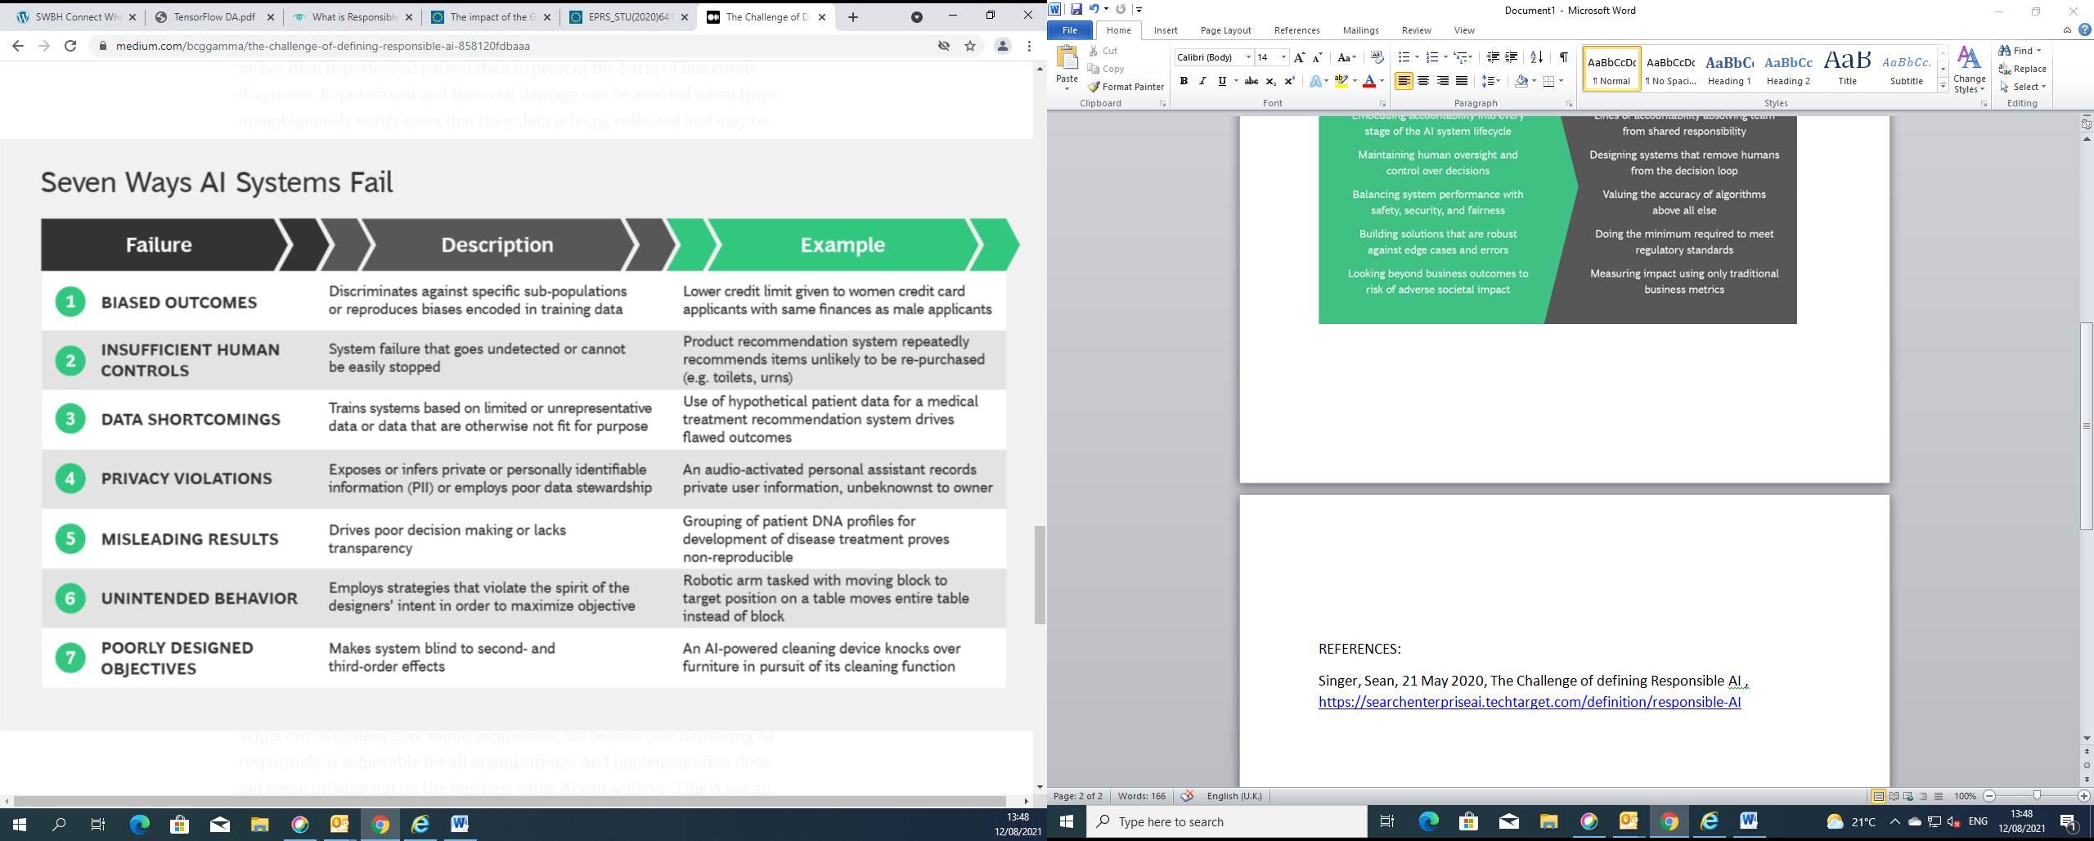

Table 2

There are issues that the Companies need to face on, not just focussing on bias and fairness but also on ensuring systems that they will use are safe and robust.

REFERENCES:

Singer, Sean, 21 May 2020, The Challenge of defining Responsible AI , https://searchenterpriseai.techtarget.com/definition/responsible-AI

Guide to the General Data Protection Regulation (GDPR) 22 March 2018 https://assets.publishing.service.gov.uk/government/uploads/system/uploads/attachment_data/file/711097/guide-to-the-general-data-protection-regulation-gdpr-1-0.pdf

The impact of the General Data Protection Regulation (GDPR) on artificial

Intelligence, June 2020 https://www.europarl.europa.eu/RegData/etudes/STUD/2020/641530/EPRS_STU(2020)641530_EN.pdf